Form Factors

🧩 What Are Form Factors?
# Source: Chatgpt (GPT-5-Mini) at [1/16/2026]
Form Factors refer to the physical shape, size, and configuration of a device, system, or component — especially in hardware and user interface design.

✅ Simple Definition:
# Source: Chatgpt (GPT-5-Mini) at [1/16/2026]
A form factor is the design and dimensions of a device or component — like how big it is, what shape it has, and how it's built.

🧠 Real-Life Analogy:
# Source: Chatgpt (GPT-5-Mini) at [1/16/2026]
Think of suitcases:
- A carry-on bag, a duffel, and a hard-shell suitcase all hold clothes
- But each has a different form factor — size, shape, usability
Devices work the same way — same function, different form factors.

Types of Server Form Factors
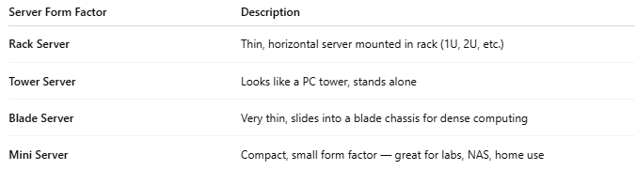
Server Form Factor | Description
Rack Server | Thin, horizontal server mounted in rack (1U, 2U, etc.)
Tower Server | Looks like a PC tower, stands alone
Blade Server | Very thin, slides into a blade chassis for dense computing
Mini Server | Compact, small form factor — great for labs, NAS, home use

